TUTORIAL – 10
AUTOMATION & REGRESSION ANALYSIS
Practical Report

Aim
To analyze the suitability of software modules for Automation Testing, prepare a regression test suite, and evaluate automation feasibility.

Description
Automation Testing runs repetitive test cases with a tool. Regression Testing checks that existing features still work after a code change or bug fix. This practical follows the supplied tutorial and uses the Student Management System as the example application.

Benefits
- Automation saves time, reduces manual errors, supports repeated execution, improves coverage, and generates faster reports.
- Regression testing checks that recent changes have not broken existing features and helps detect side effects.

Problem Statement
Analyze Login, Registration, Student Details, Search Student, and Logout modules

Implementation Details
Parameter | Details
Project Name | Student Management System
Application | Student Management System (tutorial scenario)
Modules | Login, Registration, Student Details, Search Student, Logout
Suggested Automation Tool | Selenium WebDriver
Suggested Language / IDE | Python with VS Code or PyCharm
Test Environment | Desktop browser; record the actual OS/browser used during execution
Important evidence note | The test results below are a prepared tutorial example, not a claim that a live Student Management System was accessed.

Module Analysis Table
Module | Functionality | Critical? | Changes frequently? | Automate? | Reason
Login | User authentication | Yes | No | Yes | Frequently executed; stable flow
Registration | Create a student account | Yes | No | Yes | Repeatable validation scenarios
Student Details Update | Edit student information | Yes | Yes | No | Business rules may change; automate after stabilization
Search Student | Find an existing student | Yes | No | Yes | Repeated search operation
Logout | End user session | No | No | Yes | Simple, repetitive functionality

Automation Candidate Identification
Test Case ID | Functionality | Automation Recommended | Reason | Tool
TC001 | Login | Yes | Frequently executed | Selenium WebDriver
TC002 | Registration | Yes | Stable, repetitive validation | Selenium WebDriver
TC003 | Search Student | Yes | Repeated search operations | Selenium WebDriver
TC004 | Student Details Update | No / defer | Business rules change frequently | Manual until stable
TC005 | Logout | Yes | Simple repetitive task | Selenium WebDriver

Detailed Test Case
Field | Details
Test Case ID | TC001
Requirement ID | R001
Module | Login
Feature | User authentication
Scenario | Login with valid username and password
Objective | Verify that login still works after an application update
Test Type | Regression Testing
Technique | Black-box testing
Priority / Severity | High / Critical
Precondition | Application is deployed and the login page is available
Test Data | Use a test account created for the practical
Expected Result | Login succeeds and the dashboard opens
Actual Result / Status | Pass

Regression Test Suite
Regression ID | Module | Scenario | Expected Result | Example Status
RT001 | Login | Enter valid test credentials | Dashboard opens | Pass
RT002 | Registration | Register a new test student with valid data | Registration confirmation appears | Pass
RT003 | Search Student | Search for an existing test student | Correct student record appears | Pass
RT004 | Logout | Log out from the authenticated session | Login page appears; protected page is not accessible | Pass

Automation Feasibility Report
Criteria | Observation
Repetitive test cases | Yes
Stable functionality | Yes for Login, Registration, Search, and Logout
Business priority | High for authentication and student search
Frequency | Run on each relevant build/update
Recommended tool | Selenium WebDriver
Recommendation | Automate stable, repetitive flows; keep frequently changing Student Details Update under manual testing until stable

Checklist
- Screenshot 1: Open the Selenium web form
- Screenshot 2: Submit form with sample text and show the resulting confirmation page.
- Screenshot 3: Show the automation test run in your IDE or terminal after running it.

Sample Selenium Python test
# Install: pip install selenium
from selenium import webdriver
from selenium.webdriver.common.by import By
driver = webdriver.Chrome()
try:
driver.get("https://www.selenium.dev/selenium/web/web-form.html")
assert driver.title == "Web form"
driver.find_element(By.NAME, "my-text").send_keys("Regression test")
driver.find_element(By.CSS_SELECTOR, "button").click()
message = driver.find_element(By.ID, "message").text
assert message == "Received!"
print("PASS: form submission still works")
finally:
driver.quit()

Q&A
1. Which testing technique verifies functionality without examining source code?
A) White-Box Testing
B) Integration Testing
C) Black-Box Testing
D) Unit Testing
Answer: C) Black-Box Testing
2. Which testing technique requires knowledge of internal program code?
A) System Testing
B) Black-Box Testing
C) Acceptance Testing
D) White-Box Testing
Answer: D) White-Box Testing
3. Integration Testing is mainly used to verify:
A) Database performance
B) Communication between modules
C) Source-code formatting
D) UI design
Answer: B) Communication between modules
4. System Testing validates:
A) Individual functions only
B) One module only
C) Complete application behavior
D) Database tables only
Answer: C) Complete application behavior
5. Which testing checks execution paths and branch coverage?
A) Black-Box Testing
B) White-Box Testing
C) Regression Testing
D) Usability Testing
Answer: B) White-Box Testing
6. When is Regression Testing normally performed?
A) Only before coding
B) After a change or bug fix
C) Only during UI design
D) Only after project closure
Answer: B) After a change or bug fix
7. Which module is a strong automation candidate when stable and frequently used?
A) A frequently changing feature
B) Login
C) An undocumented feature
D) A one-time manual migration
Answer: B) Login
8. Which tool is recommended in this tutorial for browser automation?
A) Selenium WebDriver
B) MS Paint
C) Notepad only
D) Calculator
Answer: A) Selenium WebDriver
9. Why might Student Details Update be deferred from automation?
A) It is always unimportant
B) Business logic changes frequently
C) It cannot be tested
D) It has no inputs
Answer: B) Business logic changes frequently
10. What should a regression test suite confirm after an update?
A) Only that the color changed
B) Existing features still work
C) That no tests are run
D) That all code is deleted
Answer: B) Existing features still work

Observation and Output
- Five modules were analyzed.
- Four stable modules are recommended for automation.
- Four regression cases were defined for re-execution after updates.
- Student Details Update should be reviewed manually while business logic changes frequently.

Conclusion
Automation testing improves repeatability and efficiency for stable flows. Regression testing checks that existing features continue to work after changes. The final Pass/Fail results and screenshots must be updated with evidence from an actual run on the target application.

llustrative Screenshot Evidence
The following images are illustrative mockups designed to match the style of a browser-based automation practical. They are not screenshots captured from a live website. For official evidence, open the linked Selenium page, run the test, and replace these mockups with your own actual screenshots.

Screenshot 1: student test data
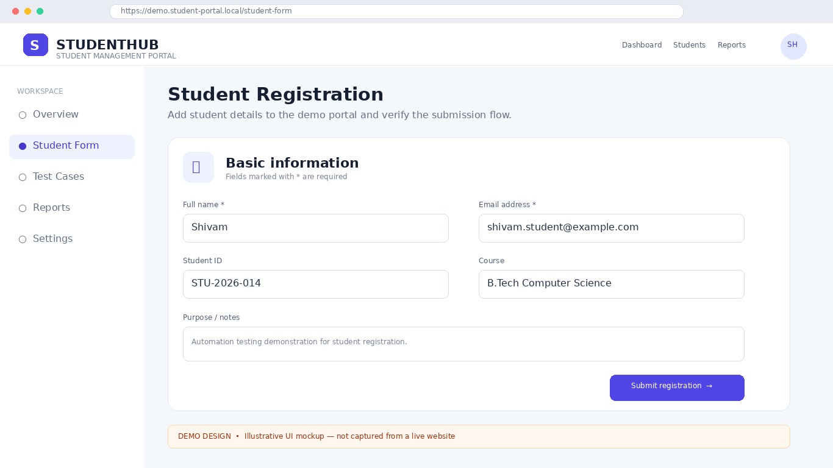

Screenshot 2: Expected confirmation state
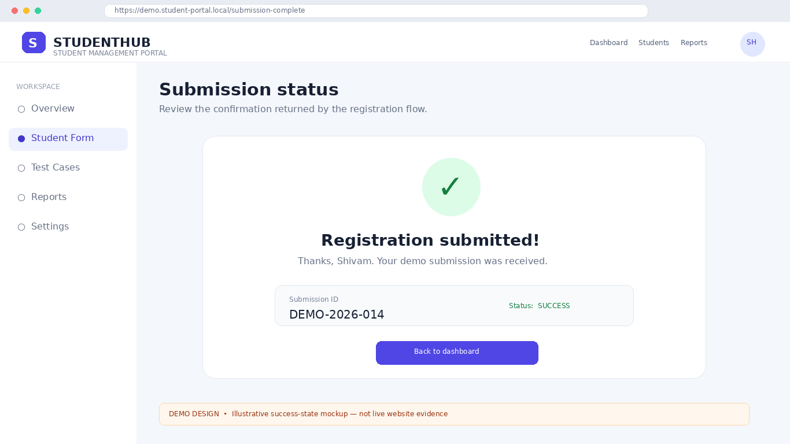

Screenshot 3: Example automation run
